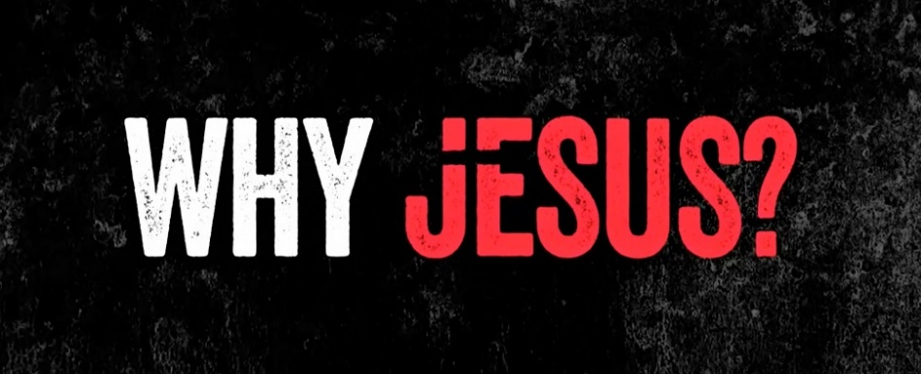
Week 7:
Because He is our Risen Savior

INTRODUCTION

Gospel is a word that simply means good news. What was some good news you received recently? How did it make you feel?

DISCUSSION QUESTIONS
- 1 Corinthians 15:3-5 gives us a concise statement of the gospel of Jesus. What does it mean for you that Jesus died for your sins?
- Jesus was raised to life on the third day. Why is his resurrection so important?
- Read Isaiah 53. Why do you supposed that Jesus would have went through the pain of crucifixion for you? How do you think you should respond?
- What kind of transformations have you made in your life because of Jesus’ resurrection?
- What kind of transformations do you still need to make in your life that you need Jesus’ help with?

STEPPING FORWARD

Jesus tells us that he wants us to share the message of his love for people with as many as we can. One of the tools we have been using at CCMC for that is your One Life. This week go the extra mile for your One Life to show them the love that Jesus has for them.

He is not here; he has risen, just as he said. Come and see the place where he lay.
Matthew 28:6

