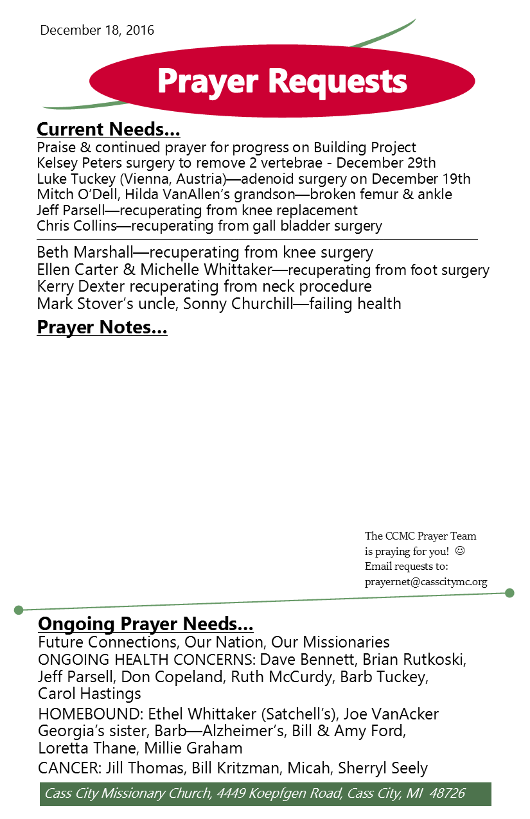
Big Idea: Like Mary, you should be available to God in three ways.

I. Available to Respond to God’s m________ Luke 1:26-33
- God’ message is p__________
- God’s message expresses His g________
- God’s message p_________ us to J__________
Galatians 4:4-5; Hebrews 1:1-2

II. Available to Receive God’s g____ of l_____ Luke 1: 34-35
- God gave His life to Mary—v________ b_______
- God gives His life to us—n_____ b________
John 3:3; 1John 5:1; Colossians 1:27b; Galatians 2:20

III. Available to Cooperate w/ God’s p______ Luke 1: 36-38
- Mary cooperated because she was c___________ in God
Isaiah 41:10; Philippians 4:13
- Mary cooperated by s____________ to God‘s plan

