Week 1:

We are generous because we are blessed

INTRODUCTION
Do you see yourself as a generous person? Talk about how you like to be generous with others

DISCUSSION QUESTIONS
- What do you think the difference is between giving to others and being generous?
- On Sunday Pastor Phil said it was our mindset, not our income, that determines our generosity. Do you agree?
- What do you think the connection is between fear and generosity?
- In an abundance mindset, we give, God multiplies, and our faith grows. Have you experienced this cycle in your life? Talk about it.
- Do you feel like tithing is important? What are some of the benefits of it?

STEPPING FORWARD
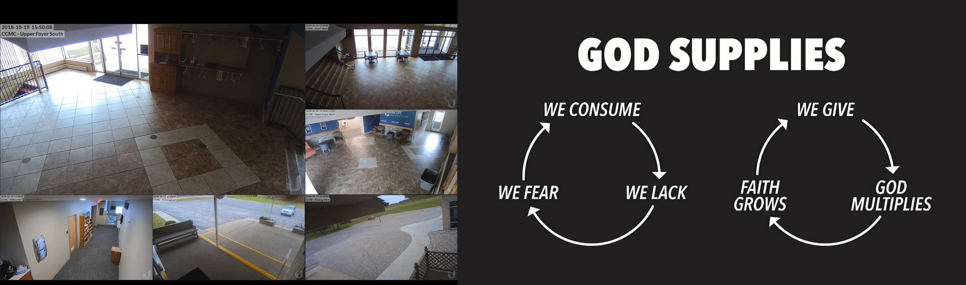
The circle on the left is the cycle of scarcity, the circle on the right is the cycle of abundance. Which one are you living in? What are some things you can do this week to move into the cycle of abundance?

Bring the whole tithe into the storehouse, that there may be food in my house.
Malachi 3:10

