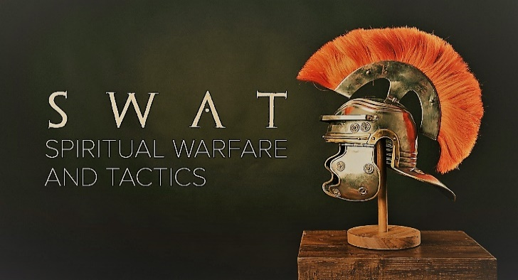

Week 6
The Sword of the Spirit

INTRODUCTION
Have you ever had an experience where a verse of scripture or lyrics from a worship song pop into your head while you are doing something else? Is it possible that the Holy Spirit is “speaking” to you in those situations? Talk about a time where that has happened to you and how it impacted the situation you were dealing with.
DISCUSSION QUESTIONS
- On Sunday pastor Phil taught that the sword is a shorter weapon meant for close combat. Have you ever been in a situation where you felt you were in close combat with Satan? Talk about it.
- Talk about a time in your life when you heard someone talking about a scripture verse that spoke directly to a situation you were dealing with. How did that make you feel?
- Do you think it’s possible that God works through the Bible to impact people’s lives? Talk about how that happens for you.
- Read Matthew 4:1-11. What are some of the things you notice about how Jesus responded to Satan’s attacks?
- The Bible can only be a weapon against Satan if you use it. What are some ways that you could increase the amount of time you spend reading your Bible?
STEPPING FORWARD
We all have things in our lives that we struggle with. Usually the Bible has something to say about those areas. This week find some Bible verses that speak to what you’re dealing with and either memorize them or write them down and refer to them each time you feel yourself struggling.

Trust in the LORD with all your heart and lean not on your own understanding

Proverbs 3:5

