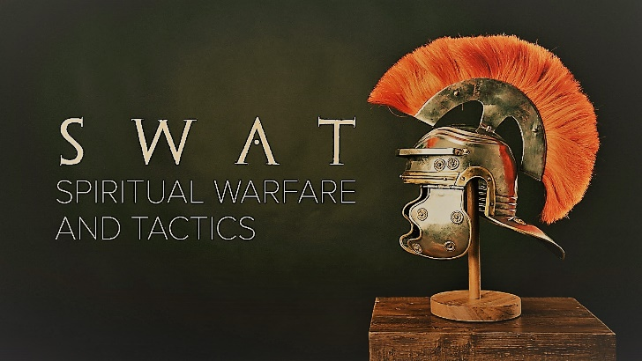

Week 5
Helmet of Salvation

INTRODUCTION
At some point, all of us get into situations that we can’t get ourselves out of on our own. Talk about a time in your life when you were in trouble and needed to be saved by someone else.
DISCUSSION QUESTIONS
- To wear God’s helmet of salvation, you have to have been saved from death by your faith in Jesus Christ. Have you? Talk about the experience.
- Wearing the helmet of salvation means that our minds begin to be transformed by God. In what ways has your mind been transformed?
- Read Romans 8:5-6. In what ways do you need to change your thinking to better reflect God’s thoughts?
- Read 2 Corinthians 5:7. In what ways do you need to see the world differently than you currently do?
- Read Isaiah 30:21. What do you have to do to be able to hear God’s voice better in your life?
- Read Psalm 141:3. Is there anything you can do to make your speech reflect God more than it does right now?
STEPPING FORWARD
Satan is constantly lying to you about yourself, but God wants you to know the truth about you – You are Holy, Loved, Chosen, Forgiven, Important, and Special to God. This week, if you begin to struggle, read those truths about yourself and know that God thinks you are amazing!

See what great love the Father has lavished on us, that we should be called children of God! And that is what we are!

1 John 3:1

