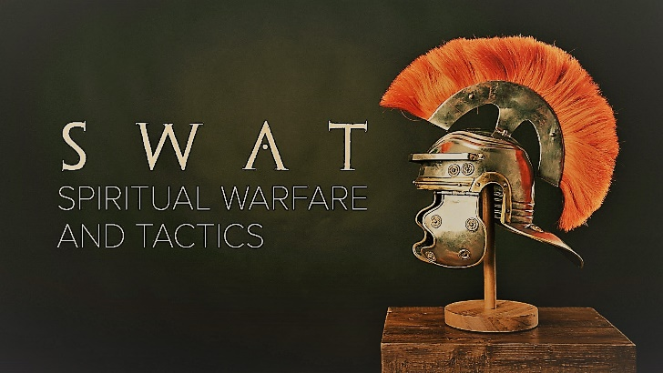

Week 3
Boots of Peace

INTRODUCTION
So much of life is struggle and conflict and juggling schedules and getting places on time. When was the last time you took a break from it all? Talk about a time in your life where you had peace or were able to step back and get some good rest.
DISCUSSION QUESTIONS
- Read Romans 6:6-7. Have you stepped into Christ’s death? How does fitting one of your feet with Christ’s death bring you peace?
- Read Romans 6:8-11. Have you stepped into Christ’s resurrection? How does fitting your other foot with Christ’s resurrection bring you peace?
- Satan’s goal is to damage your heart but read Philippians 4:6-7. How does God guard your heart from Satan’s attacks? What do you have to do for Him to protect you?
- On Sunday, pastor Phil talked about distinguishing Satan’s thoughts and God’s thoughts; what are some of the ways you can know if a though is from God or Satan?
- What are some ways you can promote peace in your life and in the lives of those around you?
STEPPING FORWARD
This week, when circumstances threaten to steal the peace of God from you, turn to Him in prayer and ask for His protection. Compare the results with doing things your own way and see which one actually brings you peace.

Peace I leave with you; my peace I give you. I do not give to you as the world gives. Do not let your hearts be troubled and do not be afraid.

John 14:27

