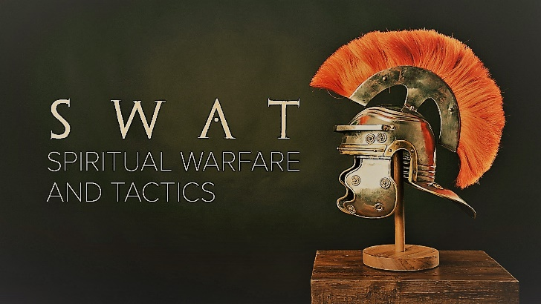

Week 2
Breastplate of Righteousness

INTRODUCTION
Righteousness is right-ness; it is living that aligns with God’s expectations. Often this is important when things aren’t going our way. Was there ever a time in your life, maybe when you were a kid, where you did something wrong to someone because of how they treated you, because they deserved it?

DISCUSSION QUESTIONS
- Unconfessed sin is the opposite of righteousness, it opens the doors for Satan’s attacks. Have you ever had a time in your life where you were concealing sinful behavior and it escalated?
- Confessing sins and repenting and living rightly purges those things from our lives. Talk about a time where you came clean on something you did wrong and how it made you feel.
- Proverbs 4:23 says “Above all else, guard your heart, for it is the wellspring of life.” Your heart has 4 parts – your mind, will, emotions, and conscience. Talk about the struggles you have in these areas, how can living rightly help with those struggles?
- Personal righteousness always fails. You were never meant to be righteous on your own – Jesus is the only one capable of 100% rightness. Submitting to Him allows your heart to be protected from Satan. Do you find it hard to submit to Christ? What are some things that you think could help you do so?

STEPPING FORWARD
This week, focus on your thoughts, your feelings, your desires, and your conscience. Are there things happening in you that you need to confess to Jesus? If there is do so and receive His protection against the evil one.

God made him who had no sin to be sin for us, so that in him we might become the righteousness of God

2 Corinthians 5:21

