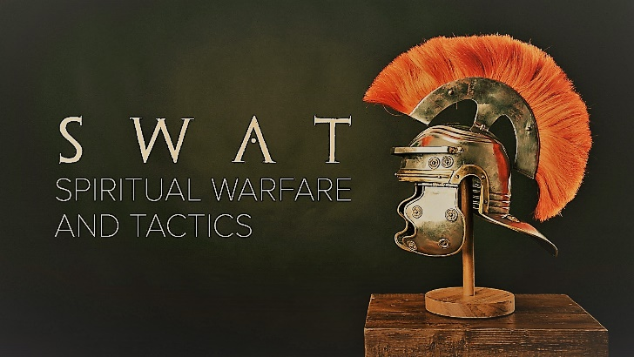

Week 1
This Means War

INTRODUCTION
We tell lies for various reasons. Talk about a time in your life you lied to someone or tried to cover something up and eventually had to tell them the truth. How did the lie effect your relationship? How did the truth effect it?

DISCUSSION QUESTIONS
- How open are you to believing in dark spiritual forces? Why do you think that way?
- Satan uses many strategies to destroy us; he accuses us in order to keep us tied up in guilt. What are some of the things Satan tells you that keep you from living fully?
- Satan also lies to us, often about God. What are some lies that you’ve believed about God?
- He also uses our passions against us – what are some temptations you deal with or have dealt with?
- Often the struggles we have in life are symptoms of the spiritual battles we are in. What do you think are some ways to deal with the real problem of the spiritual enemy rather than just the symptoms?
- The truth is a tool God gives us to fight Satan. What are some truths about yourself you should start believing?

STEPPING FORWARD
This week spend some time in prayer asking God to reveal the lies that Satan has told you about yourself. Then spend some time reading through Bible verses about your identity in Christ and how special you are to God.

Jesus answered, “I am the way and the truth and the life. No one comes to the Father except through me.”
John 14:6

