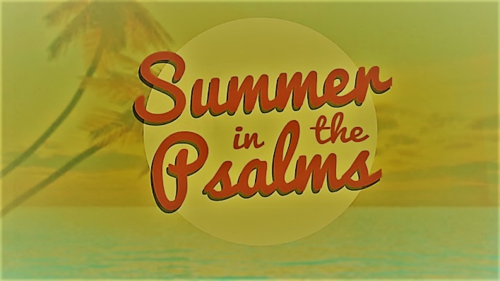

Week 2

Psalm 150

INTRODUCTION
This week pastor Phil talked about worship. Talk about some of the best worship experiences you have had. Why were they so impactful?

DISCUSSION QUESTIONS
- Does it change how you view your worship of God if you think that worship originates from God? Why or why not?
- We see in the books of Revelation and Hebrews that Heaven is constantly worshipping. What are the keys to join in the worship that is already going on in heaven?
- Verse 2 of Psalm 150 says to praise God for His acts and His greatness. What are some ways you can worship God for the things He’s done? What are some ways you can worship God for His greatness?
- Pastor Phil said that the reason we exist is to glorify God and enjoy Him forever. What are some ways you can do that?

STEPPING FORWARD
This week consider how you worship and who you do it for. Read Psalm 150 again. Are there some ways you could worship God that you see in the psalms that you have been holding back from?

The heavens declare the glory of God; the skies proclaim the work of his hands.

Psalm 19:1

