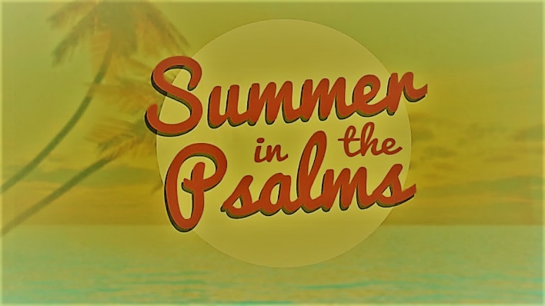

Week 1
Psalm 1

INTRODUCTION
Psalm 1 is all about how to be happy. Talk about some of the happiest moments in your life – what was going on, who was involved, and why was the experience such a positive one for you.
DISCUSSION QUESTIONS
- Psalm 1 says that happy people are defined by the company that they keep. Talk about how your friends influence you – is it for good or bad?
- According to Psalm 1 happy people delight in the law of the Lord and meditate on it regularly; how do you feel when you read the Bible? How do you think you could find more delight in it?
- Meditating on God’s Word should change you. How have you been changed by the Bible?
- Psalm 1 describes happy people as righteous, but it also describes a second group of people – the wicked. What makes these two groups of people different? How can you know which group you’re in?
- Read Isaiah 55:6-7. What does it say God’s response is to those who turn from wickedness towards Him? How does that impact you and the people around you?
STEPPING FORWARD
Psalm 1 gives us the same message as the rest of the Bible – either you have a relationship with Jesus and are considered righteous or you don’t and are considered wicked – the righteous will prosper, the wicked will perish. This week think about the people you know – which side are they on? Is there anything you can do to help them change sides?

Small is the gate and narrow the road that leads to life, and only a few find it.

Matthew 7:14

