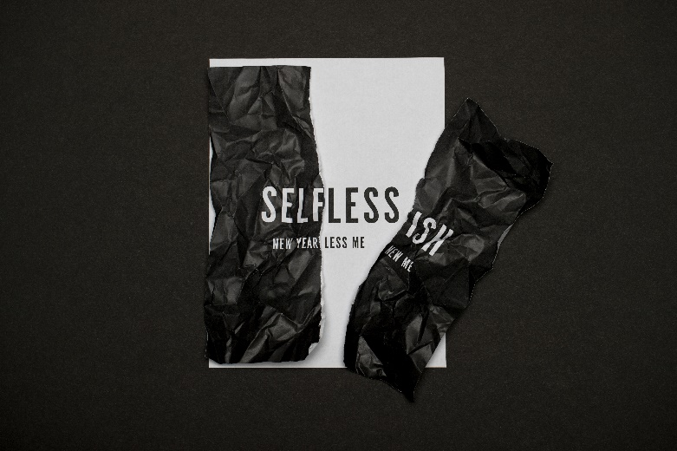

Week 3
Extravagant in Generosity

INTRODUCTION
On Sunday, pastor Joel talked about some of the different things we did as a church over this past year. Share some of your favorite memories about a church activity in 2018.

DISCUSSION QUESTIONS
- On a scale of 1-10, how generous are you? Why that number?
- Read Proverbs 3:9-10. Why do you suppose God wants us to give back our wealth to Him first?
- What do those verses say about what will happen to you if you give to God first? Do you believe that is true?
- Share an example in your life where you gave to God first.
- Talk about a time during 2018 that you gave your time, attention, knowledge, or wealth to someone else; what was the best part of that experience?
- What is the scariest thing about giving more of what you have? How do you think you could overcome that fear?

STEPPING FORWARD
This week, ask God for specific opportunities to be generous. Then, obey and see what He does.

Also, consider going through the six-day Selfless reading plan on the YouVerion Bible app this week.

Give, and it will be given to you. A good measure, pressed down, shaken together and running over, will be poured into your lap. For with the measure you use, it will be measured to you.
Luke 6:38

