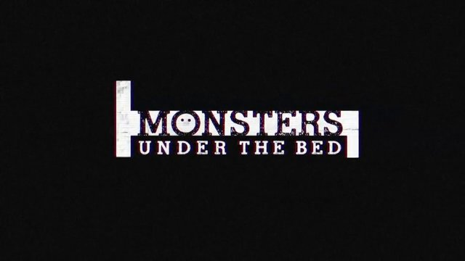

Week 1
Dark Night

INTRODUCTION
Most of us had some kind of monster we were afraid of when we were kids, they lived under our beds, in the closet, in the dark, or somewhere like that. Talk about something you were afraid of when you were a kid. What types of strategies did you develop to deal with those monsters?

DISCUSSION QUESTIONS
- We all have our good days and bad days that fit into the realm of “normal”. Talk about a bad day you had recently.
- Monsters are those things that continue to impact us that we can’t get rid of no matter how hard we try, they keep rearing their heads and go beyond the scope of a bad day. People often struggle to talk about the monsters in their lives, why do you suppose that is? Do you think that fear is justified, or should we spend more time talking about our monsters?
- Read Matthew 9:12-13. What do you suppose the difference is between the healthy people and the sick people in this story?
- A major step in Jesus helping you with the monsters in your life is to admit that the monsters exist and to name them; so, do you have a monster? What is it?
- What would it take for you to get help for your monster?

STEPPING FORWARD
Healing begins when we start to embrace humility and admit our brokenness. This week spend time in prayer asking God to reveal any monsters that you are hiding from yourself.

“The Spirit of the Lord is on me, because he has anointed me to proclaim good news to the poor. He has sent me to proclaim freedom for the prisoners and recovery of sight for the blind, to set the oppressed free, to proclaim the year of the Lord’s favor.”
Luke 4:18-19

