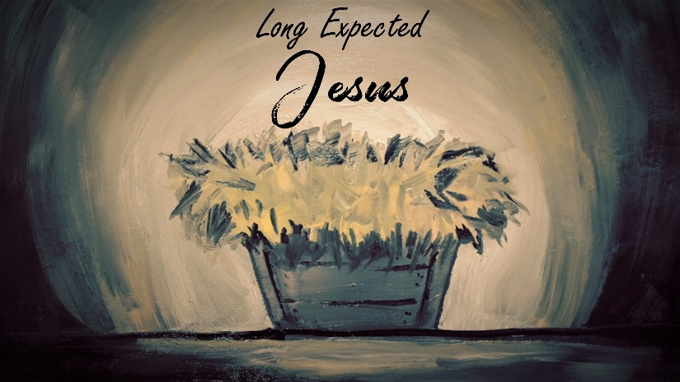

The Return of the King

INTRODUCTION
The Bible gives us some glimpses of what the world is going to look like when Jesus returns. The battle between Jesus and Satan, no more tears or pain in the world, etc. Take a moment and speculate about what things you are looking forward to when Jesus ushers in the New Heaven and New Earth.

DISCUSSION QUESTIONS
- When Adam and Eve rejected God, there were a number of curses that God announced to them. Frustrated labor, pain, and death were a part of those curses. Why do you suppose God imposed the curses He did?
- When Jesus came to Earth, he reversed the curse of death for us by taking on the penalty of our sins (see Galatians 3:13 and 2 Corinthians 5:21). What does it mean to you that Jesus did that?
- Read 1 Peter 2:9. Our participation in Christ’s death and resurrection gives us a new identity. Talk about that new identity, is it easy for you to grab a hold of, or do you struggle with living like you did in the past?
- When Jesus comes back the Bible also says that we will reign on the earth. Have you ever thought about what that means? What do you think about the idea that you will help reign when Jesus comes back?
- Read Revelation 22:1-5. What does this image say to you?

STEPPING FORWARD
This week, consider what it means to live your life focused on your eternal home. Are there some things that you need to change about the things you do when viewed from this perspective? If so, think about how you can make those changes.

Here I am! I stand at the door and knock. If anyone hears my voice and opens the door, I will come in and eat with him, and he with me.
Revelation 3:20

