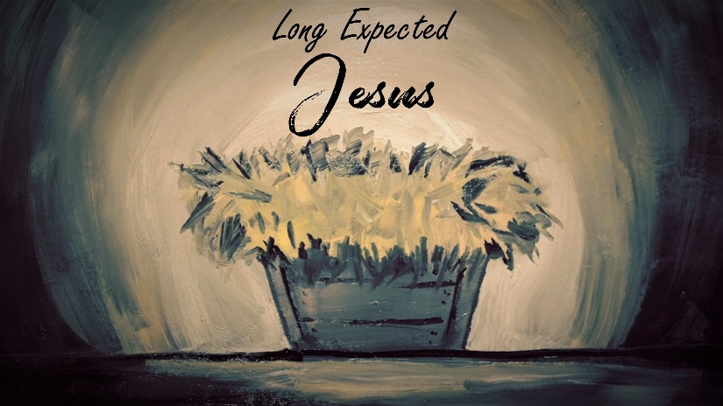

Moses

INTRODUCTION
Obviously, one of the things that Moses was a part of that is truly amazing is when God parted the Red Sea for the Israelites. Have you ever had God do something amazing in your life? If so, talk about it. If not, how do you think you’d react to a miracle?

DISCUSSION QUESTIONS
- God used Moses to deliver the Hebrews from bondage in Egypt. How do you think Moses felt when God asked him to go back to Egypt and rescue His people?
- Pastor Phil said that you are in bondage to whatever controls you. He then gave some examples: fear, envy, greed, pride, lust, anger and resentment. Do any of these things control you? Is there something else controlling you?
- When God asked Moses to go back to Egypt, Moses knew it was a bad idea. He had killed an Egyptian and was intimately aware of how powerful Pharaoh was. He had to choose to trust God and leave his old identity behind. Jesus did the same for us in coming to earth – he chose to be one of us. Talk about why he would do that.
- God sent Jesus to free you from the bondage of your sin. Think about your answers to question 2 and ask Jesus to deliver you from the things that are controlling you.

STEPPING FORWARD
This week, listen to the story of The Man and the Birds by Paul Harvey found here: https://www.youtube.com/watch?v=ddai8rkXWRs Does this story help you understand what Jesus did for you? How can you help others see what Jesus did for them?

Christ died for sins once for all, the righteous for the unrighteous, to bring you to God
1 Peter 3:18

