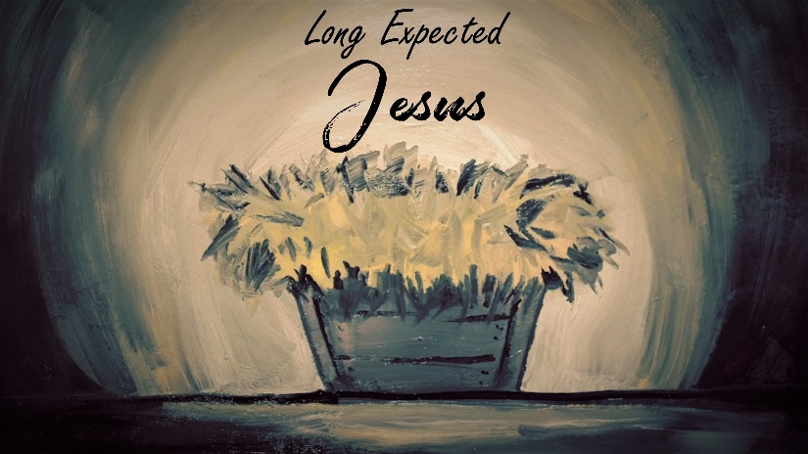

Abraham

INTRODUCTION
On Sunday, pastor Joel talked about the incredible generosity Abram showed after rescuing Lot from his captors. What are your thoughts on generosity? Is it an important part of your life?

DISCUSSION QUESTIONS
- In Genesis 15:1 God speaks to Abram in a vision and tells him not to be afraid, that He was his shield. What is the purpose of a shield? What do you think about the idea of God as your shield?
- God had promised Abram children over a decade before He speaks to him in Genesis 15. What do you imagine Abram was thinking or feeling about God keeping his promise after so much time had gone by? Do you ever get discouraged about God working in your life?
- Abram had a back-up plan, to make Eliezer his heir. Do you ever make back-up plans for God?
- Genesis 15:7-21 outline a covenant made between God and Abram. In it God tells Abram that his descendants will occupy the land God had set aside for them. What does it say about God’s character that He was willing to reassure Abram by making a covenant with him?
- To ratify the covenant God, in the form of a firepot and torch, passed between the pieces of the animals, meaning that God would be willing to pay the penalty if the covenant was broken. How does this add to your view of Jesus sacrificing his life for you?

STEPPING FORWARD
Abram had to wait a long time for God’s plan for his life to unfold. This week, spend some time working with God figuring out His plan for your life; then, make the determination to wait on God’s instructions rather than helping Him accomplish His goals for you.

But he was pierced for our transgressions, he was crushed for our iniquities; the punishment that brought us peace was on him, and by his wounds we are healed.
Isaiah 53:5

