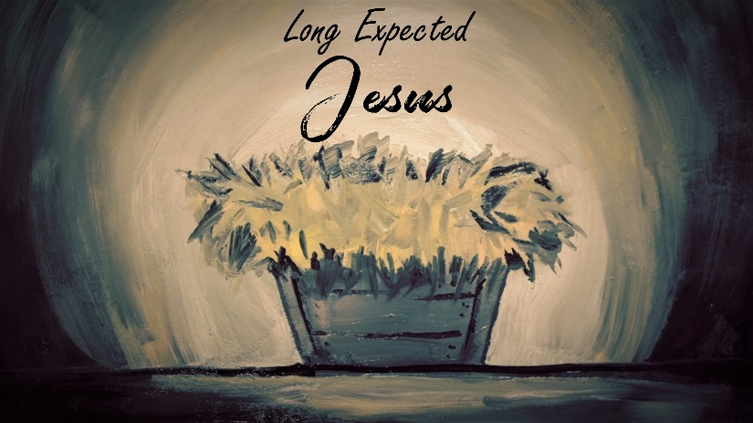

Adam and Eve

INTRODUCTION
Ever since Adam and Eve ate the forbidden fruit, the world waited in anticipation for Jesus to come. Ever since Jesus ascended to heaven, the world has been waiting for him to return. Talk about something in your life you had to wait a long time for. Did having to wait for that thing change how you viewed it?

DISCUSSION QUESTIONS
- Read Genesis 2:15-17 and 3:1-5. What are some of the differences between what God said and the conversation between Eve and the serpent?
- Have you ever imposed extra rules on top of what God tells us to do (like Eve did)? Why or why not?
- In Genesis 3:6 we see Eve convincing herself (based on Satan’s deceit) that eating the fruit would be a good thing. Has there ever been a time in your life when you convinced yourself to do something you knew was wrong? Why do you suppose we do that?
- Read Genesis 3:14-24. Because of sin, God imposed many curses upon Adam, Eve, the serpent, and the world. Why do you suppose He did that? Is it fair?
- Verse 21 tells us that even in the midst of rebellion, God was willing to care for Adam and Eve. Talk about a time in your life when God took care of you when you didn’t deserve it.

STEPPING FORWARD
The Bible gives us our first glimpse of Jesus in Genesis 3:15. It would be centuries before He came, but people were given hope that the mistakes they made in life didn’t have to be permanent ones. This week reflect on some of the mistakes you’ve made and ask Jesus to forgive you for them.

But he was pierced for our transgressions, he was crushed for our iniquities; the punishment that brought us peace was on him, and by his wounds we are healed.
Isaiah 53:5

