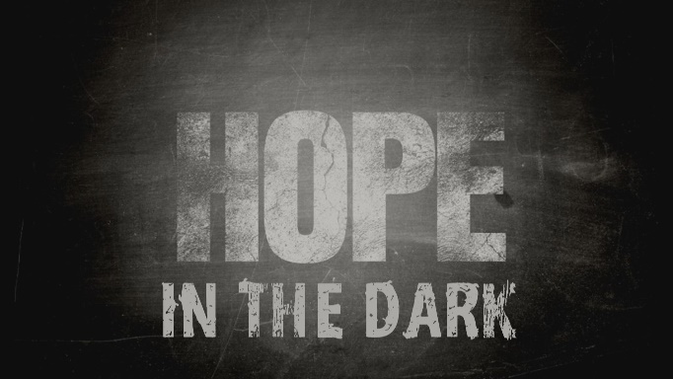

Week 5
Hope Beyond the Dark

INTRODUCTION
All of us end up in situations we don’t want to be in that we can’t seem to get out of, in short we need help. Talk about a time in your life when you needed someone to get you out of a jamb you were in.
DISCUSSION QUESTIONS
- The Bible tells us that all of us need to be redeemed; what are the things you need redemption from?
- Once redeemed through Jesus, we are called to be a witness and a blessing; how does that look in your life/how would you like to be those in your life?
- The point of redemption is always a new life, what do you think about the idea that God wants you to live your life differently?
- God’s hope is that once redeemed we become fruitful; what does that mean to you and what are some things you do to be fruitful?
- In Ruth, God uses something considered worthless (a child-less widow) to bring about great change and add great value to people’s lives. Is there anyone/anything considered worthless in your life that God could use for great things?
STEPPING FORWARD
Ruth’s story is one of redemption. Jesus’ story is that of a redeemer. This week consider how you fit into God’s story of redemption and spend some time thinking about if there’s anything else in your life God might want to use in His story.

Repent, then, and turn to God, so that your sins may be wiped out, that times of refreshing may come from the Lord
Acts 3:19

