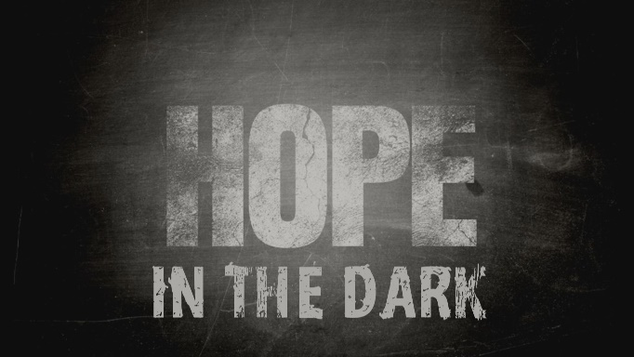

Week 4
Hope Takes Shape in the Dark

INTRODUCTION
Happy Mother’s Day! Mothers are usually our earliest source of love, comfort, sustenance and many other things. Spend some time talking about your mother with your group.
DISCUSSION QUESTIONS
- In Ruth 3, Naomi has some prophetic insights about Ruth and Boaz and helps position them to follow God’s plan. Have you ever had another person help move you down God’s path? Talk about it.
- Ruth continues to follow Naomi after committing to her in chapter 1, what are some of the ways she lives out that commitment in chapter 3?
- In this story Ruth continued to serve and follow God until she was in a position to restore the fortunes of her family. How has God led you towards a restoration in your life?
- Naomi and Ruth were in troubled circumstances, yet God used those circumstances to help them rest and find the path forward that He was giving them. Is it possible that the Covid 19 quarantine is a time of rest for you?
- Just like Boaz was to Ruth, Jesus is our kinsman-redeemer. He offers to buy away all your sin, guilt, shame, and death. Have you made Jesus the Lord of your life?
STEPPING FORWARD
In dark times God is often laying the foundation to make a positive impact in your life and the lives of those around you. This week, look for things that God is building in you and around you and try to imagine where He is taking you.

Come to me, all you who are weary and burdened, and I will give you rest.
Matthew 11:28

