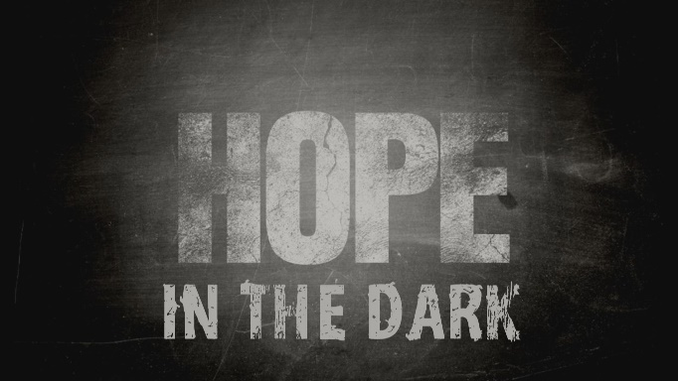

Week 3
Hope Grows in the Dark

INTRODUCTION
Sometimes in bad situations the best thing to do is what you can do instead of worrying or complaining about what you can’t do. Positive action often causes hope to grow. Talk about a time when you were in a situation where it seemed like you didn’t have any good options and you had to find a way to move forward.

DISCUSSION QUESTIONS
- What is something positive you can do even with the restrictions that are in place?
- Stepping out in faith can often be a key to unlock the blessing God has in store for you; have you ever experienced God redeeming a situation when you took a positive step forward?
- Acts of kindness often have a bigger impact than we realize, talk about a time where someone was kind to you that changed your circumstances significantly.
- Encouragement causes hope to grow; who have you encouraged lately?
- Generosity causes hope to grow; who have you been generous towards lately?

STEPPING FORWARD
Ultimately hope grows when we see God working. This week, take some positive steps and put yourself into a position to see God work through you.

We know that in all things God works for the good of those who love him, who have been called according to his purpose
Romans 8:28

