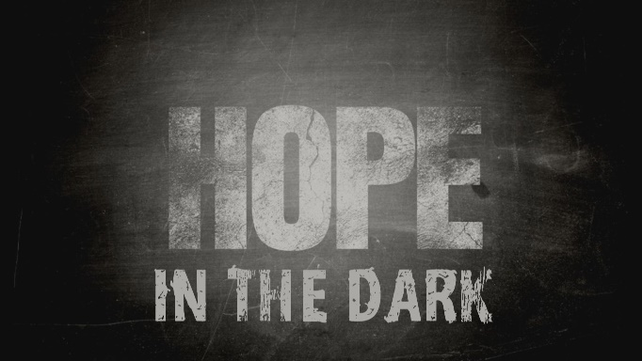

Week 2
Hope Born in the Dark
INTRODUCTION
Life and suffering are a package deal. All of us spend at least a little bit of time in dark places and have to make decisions while we’re there. How we make decisions and the things we choose in dark times are important not only for the dark times themselves but as you come out the other side.

DISCUSSION QUESTIONS
- In Ruth chapter 1 Naomi was convinced that God had turned against her; have you ever had a time where you felt like God was against you?
- Sometimes hope is born with something as simple as a decision to follow God, talk about the time when you decided to follow God. How has that impacted your life?
- Ruth was obviously mentored by Naomi over the years they knew each other; have you had a godly mentor in your life or been a mentor for someone else?
- God loves you more than you can imagine; how does that fact make you feel?
- What kinds of struggles has this pandemic created for you? What are your temptations to turn from God?
STEPPING FORWARD
This week consider the choices you have that can bring you closer or further from God. Try to decide to move closer to him with your decisions.

But from everlasting to everlasting the LORD’s love is with those who fear him, and his righteousness with their children’s children —
Psalm 103:17

