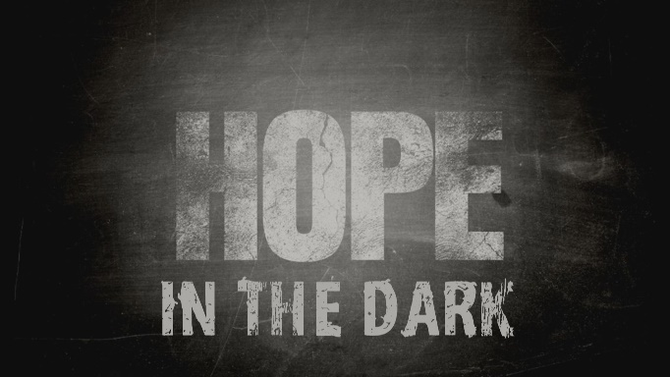

Week 1
Glimmers in the Dark
INTRODUCTION
Over the past few weeks, dark times have come upon us. How have the restrictions and the coronavirus affected you?

DISCUSSION QUESTIONS
- Elimelek moved his family to a foreign country in order to get away from a famine in Bethlehem. Have you ever had to uproot your family because of economic concerns?
- While in Moab, Naomi lost her husband and both sons. What do you suppose she felt at that time? How do you think Orpah and Ruth felt?
- Naomi decided to go back home and throw herself on the mercy of her childhood friends, talk about a time in your life when you had to put your future in someone else’s hands.
- In chapter 1 it seems like everything that could gone wrong has for Naomi. Have you ever had a day like that (or week or month or year)?
- How hard is it for you to allow yourself to be loved?
STEPPING FORWARD
This week take some time to consider how the past few weeks have changed your circumstances. Rather than focus on negatives, focus on the glimmers of hope you can see.

Where you go I will go, and where you stay I will stay. Your people will be my people and your God my God.
Ruth 1:16

