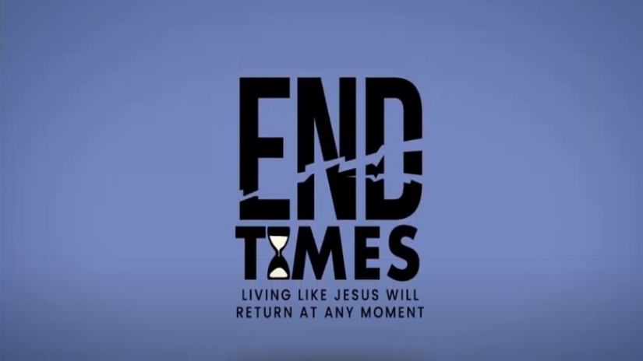

Week 7: Scene Shifts & Significant Signs II

INTRODUCTION
Christians will often say “God has a plan”. Sometimes they say that when they are uncertain, sometimes they say that when bad things happen. Have you ever thought about God’s plan before? As an opening exercise, talk about what it means that God has a plan.
DISCUSSION QUESTIONS
- Revelation 13 tells the story of a dragon (Satan) and two beasts (anti-Christ, false prophet). What stands out to you about these creatures as you read through the chapter?
- Genesis 1:26 tells us that humans were given authority over the earth; how then did Satan get his authority? How does this continue today?
- Read Revelation 13:8. How does someone get their name written in the Book of Life?
- Revelation 13:16-17 talks about the mark of the beast. What are the consequences of not having this mark? What are the consequences of having the mark?
- We get our name in the Lamb’s book of life when we accept Jesus as our Lord and Savior. Have you done that?

STEPPING FORWARD
All of us have temptations and struggles and get to the point where we are at the end of our rope. This week think about some strategies you could put in place to help you the next time you reach that point.

However, do not rejoice that the spirits submit to you, but rejoice that your names are written in heaven.
Luke 10:20

