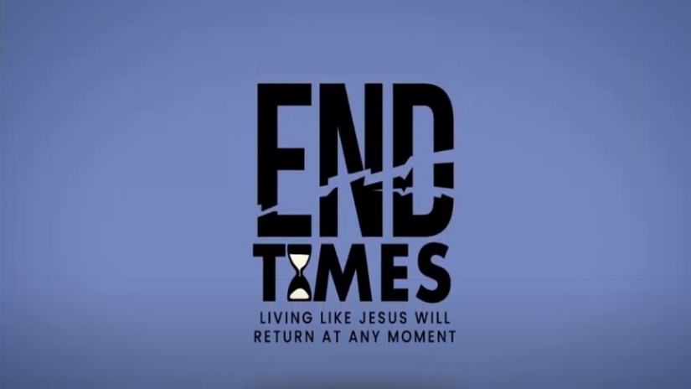

Week 6: Scene Shifts & Significant Signs

INTRODUCTION
When we know the results of a game or contest ahead of time, it changes how we experience it. Talk about a time in your life when you were playing a game you knew you couldn’t win (or knew you couldn’t lose); how did that impact how you played?

DISCUSSION QUESTIONS
- The big picture of the book of Revelation tells us that in the battle over Satan and evil God wins. How does knowing that help you live day to day?
- We are first introduced to Satan in the book of Genesis. The Bible makes it clear he is evil – Revelation refers to him as a dragon. Talk about how you have viewed Satan.
- On Sunday pastor Phil said that we are at war with Satan right now. How have you experience this war?
- In Revelation 12:11 Satan was overcome by “the blood of the Lamb and by the word of their testimony.” Are you able to defeat Satan in your life with your testimony?
- God has declared that He will fight for you in the battle against Satan, how does that make you feel?

STEPPING FORWARD
This week think about the battle you are in against Satan. Are there areas of your life in which you are losing the battle? If so, spend some time in prayer this week asking for God’s help in those areas.

Therefore put on the full armor of God, so that when the day of evil comes, you may be able to stand your ground, and after you have done everything, to stand.
Ephesians 6:13

