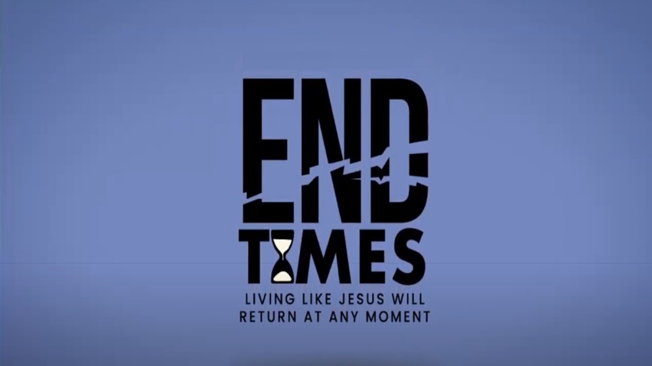

Week 1: The Center of Everything

INTRODUCTION
In Revelation 4 we get a snapshot of the throne room of God. How does that snapshot resemble your imagination of heaven? How is it different?

DISCUSSION QUESTIONS
- In verse 1 of chapter 4 Jesus invites John to heaven. How does this invitation reflect the invitation Jesus has for you?
- Read Revelation 4:6-8. What were the creatures around God’s throne doing in these verses? What does this say about God?
- Revelation 5:3 says that no one in heaven or earth was worthy to open the scroll of God’s will. What does that say about you and the people you know?
- Revelation 5:5 says that Jesus is worthy to open the scroll, what does that say about Jesus?
- Given the answer to the previous two questions, what do you think an appropriate response for you to have towards Jesus is? How does that response effect your daily life?

STEPPING FORWARD
Revelation 5:8 tells us that there are golden bowls full of our prayers used in praising God in heaven. This week, as you spend time in prayer, remember that those prayers are going straight to the throne room of heaven.

Worthy is the Lamb, who was slain, to receive power and wealth and wisdom and strength and honor and glory and praise!
Revelation 5:12

