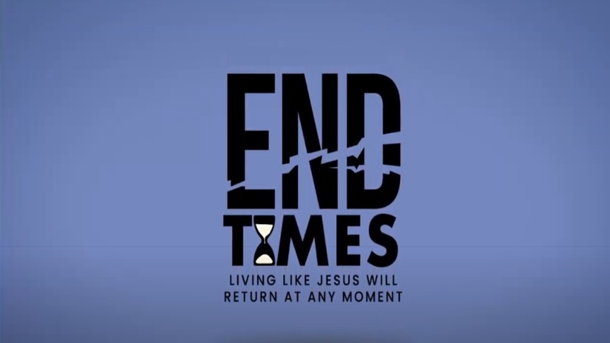

Week 1: A Beginining

INTRODUCTION
There’s a whole lot of negative things happening in the world around us. Many think that those things are a sign of the end times. How do you view the things happening in the world today – temporary happenings or signs of things to come?

DISCUSSION QUESTIONS
- Have you ever read the book of Revelation before? What did you think of it?
- The reason the book of Revelation was written to give Christians hope. How does it make you feel to know that in the end, God triumphs over evil and His followers are victorious?
- Read 2 Peter 3:11-14. What do these verses say about how to live based on the end times?
- In Revelation 1 God uses the metaphor of lampstands to represent the church. What is the purpose of a lampstand? How do you shine light around you?
- What does it mean that Jesus has the “keys of death and Hades.” Does that make a difference in how you live.

STEPPING FORWARD
Read this verse aloud this week: “Blessed is the one who reads aloud the words of this prophecy, and blessed are those who hear it and take to heart what is written in it, because the time is near.”

Here I am! I stand at the door and knock. If anyone hears my voice and opens the door, I will come in and eat with that person, and they with me.
Revelation 3:20

