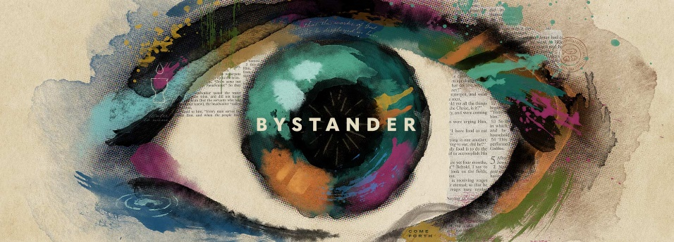

Week 5
Eyes Open
INTRODUCTION
There are many products we buy, use, and put our confidence in without having
all the information or fully understanding how they work. In the Gospel of John,
we see a man begin to follow Jesus based on limited information. This man, who
was born blind, said he only knew one main thing—and that one thing was
enough to make him curious about who Jesus really was.

DISCUSSION QUESTIONS
- What are some things people put full trust in without having all the information?
- Read John 9:1-20. In verse 2 there was the assumption that sin and suffering were connected. Were you raised to believe that?
- What do you think about the idea that suffering might have a purpose?
- Read John 9:24-25. The blind man focuses on the main thing – that he can see. How does this remind you about something that happened in your own life?
- Think of a season of your life that was difficult through no fault of your own. You may be in one currently. Is there something about that season God used (or could use) to shape your faith? If so, what?

STEPPING FORWARD
Is your view of God too small? This week think about people that you might be withholding compassion from because you think their behavior is unacceptable to God. Ask God to help you have compassion for those people.

He said, “Lord, I believe.” And he worshiped him.
John 9:38

