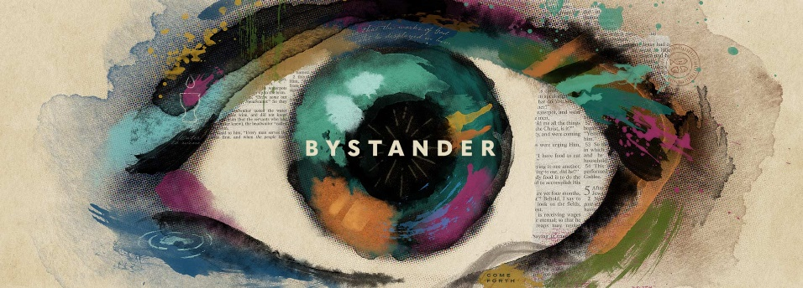

Week 1
Momma Says

INTRODUCTION
Beginning with first-century followers of Jesus, trusting in Jesus has been a response to evidence—not simply a hope that something is true. The Gospel writer John referred to the miracles of Jesus as signs that gave evidence of who Jesus was. The first sign John documented was when Jesus—with a nudge from his mother—attended a wedding and turned water into wine.

DISCUSSION QUESTIONS
- What is something you once believed without any evidence? Why did you believe it?
- How would you describe the difference between faith and belief?
- The apostle John describes coming to faith as a process that starts with seeing actual events that serve as signs of who Jesus was. Today, we can only hear or read about those events. Should the fact that we are not eyewitnesses to Jesus’ miracles affect the process of someone coming to faith? Why or why not?
- Read John 2:2-11. How familiar is this story to you? Does anything stand out as new information? What are some details about this story that would lead a reader to believe this actually happened?
- How do you think you would have reacted if you were at the wedding and witnessed what Jesus did?
- What characteristics about Jesus that come to mind as a result of this story?

STEPPING FORWARD
John calls the miracles Jesus performs “signs”. Does looking at his miracles as signs of who he was change your view about God? This week, spend some time examining the things God has done in your life, are they signs?

What Jesus did here in Cana of Galilee was the first of the signs through which he revealed his glory; and his disciples believed in him.
John 2:11

