#1 ELEMENTS—Love
I. God’s design & desire for us is to be f________ John 15
A) The n_________ & relationships of/to the vine 1-5
B) The necessity of p________ & p__________ the vine 2
C) The nexus/c__________ to the vine—remaining in Christ 4-5
II. D_________ & deciding what will help us be more fruitful
A) Pinpointing p________ that hinder fruit-bearing Ps 139:23-24
B) A practical s_________ to fruit-bearing problems Mark 1: 15
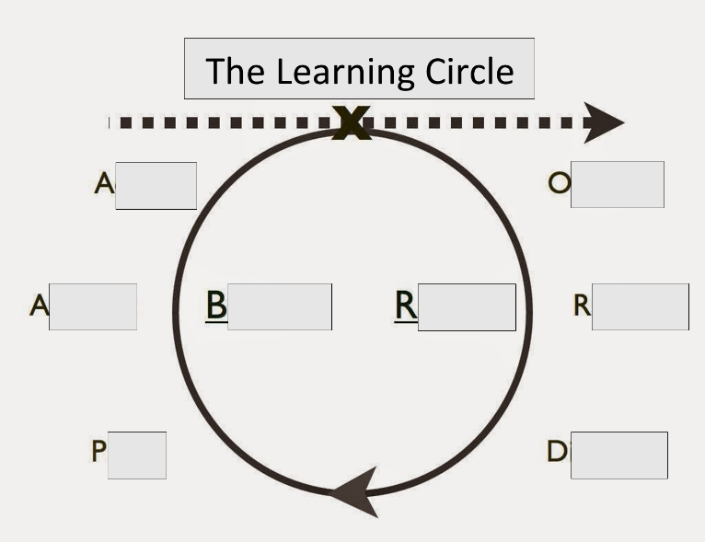
III. Developing the fruit of God-like l___: A____ 1John 4:10-12
Key Affirmation: I am committed to loving God and loving others?
A) God-like love is u_____________
B) God-like love is s___________
C) God-like love is f_____________
1John 1:9; Matthew 18:21-22; Ephesians 4:32

