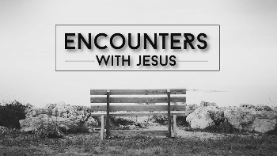
Jesus Heals a Blind Beggar
Luke 18: 35-43
- Questions
1) What does this story say about people? | 2) What does the story say about Jesus (God)?
3) Are there any sins to avoid? | 4) Are there any good examples to follow?
5) Are there any promises in the story? | 6) Who in this story reminds me of myself and why?

- People in the Story
Jesus
Blind Beggar | The Crowd

