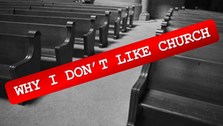
#4: I don’t find community there

Big idea: The answers to three key questions reveal God’s design for community and the steps we can take to realize it in the church.
1. Is community a problem or a possibility?
A) Community is a p____________ problem for The Church
B) Community is a stated p__________ for our CCMChurch
Philippians 2:1-4
2. What does the Bible teach us about community?
A) Community flows out from God’s n________
John 17:20-23; John 13:34-35;
B) Community was a k____ to the success of the early church
Acts 2:44-47; 4:23-32 & 5: 14
C) Community (koinonia) has clear c_____________ in the Bible
3. What steps can we take toward stronger community?
A) Set God-g_______ for community
B) Celebrate u______: coordinated d___________
Ephesians 4:11-16
C) Step outside of your “comfort zone” to c__________

