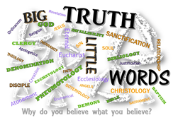

Big Idea: Answers to Seven FAQ’s will help us grasp the significance of and relate more closely to the Trinity.
Question 1: W___ i_ the Trinity? 4 words to explain the Trinity
1) O Deuteronomy 6:4
2) T________ Matthew 28: 18-20
3) C______________
4) U___________
Question 2: What d__________ does the Trinity make?
Hebrews 12:14; 4:15; John 16:8 & 13a; Romans 8:9–10
Question 3: The Trinity is hard to u_________. Can you explain that better?
Question 4: Can you give me an a_________ to understand the Trinity? 2 Corinthians 13:4
Question 5: Do we have to believe the d_________ of the Trinity? John 10:31; Colossians 2: 9; Acts 5: 3-4
Question 6: Is it okay to p_____ to any one Person in the Trinity?
Luke 23: 42; Psalm 139:23-24; Hebrews 7:24-25; Romans 8:26
Question 7: If God is a Trinity, what do I do d_________?

