Key Verse: 2 Thessalonians 2:15 So then, brothers and sisters, stand firm and hold fast to the teachings we passed on to you.
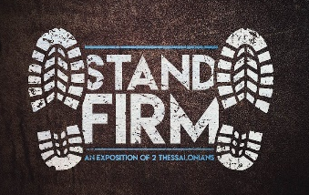
Big Idea: The third chapter of 2 Thessalonians reminds us about 3 disciplines that are necessary to stand firm.
1. Stand firm in Christian c________ 6-15
A) Stand firm…..STAND U__….and g___ to w______ 7-12
B) Stand firm in c________ re Christian b__________ 6 & 13-15
2. Stand firm in c__________ prayer 1-2
A) Pray that the gospel will a________ & be h_________ 1
Psalm 147:15
B) Pray for d___________ from evil men 2
Matthew 6:13
3. Stand firm in c_________ trust 3-5 & 16-18
A) Be confident the Lord will p________ you 3
John 17:15; Jude 1:24;1 John 5:18; Ephesians 6: 13-17
B) Be confident the Lord will p________ in His l____ to you 4-5
C) Be confident because the Lord i__ w_____ y___ 16-18

