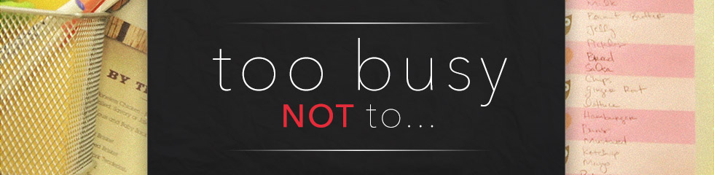
…Surrender to God
Key scripture Romans 12:1-2
Key Question: How do I live my life in total surrender to God?
Big Idea: The Bible helps us look at total surrender to God in 3 ways.
I. The Bible d______ what total surrender is NOT Luke 9:57-62
A) Total surrender is NOT….L____ service
B) Total surrender is NOT… L___________ service
C) Total surrender is NOT….L_______ service
- We must c_____ the c______ of total surrender Matthew 16:24-25
II. The Bible d_____ what total surrender means Romans 12: 1-2
A) O__________ yourself as a “living sacrifice” to God 12:1
1. …in view of God’s mercy…..
Roman Road to Salvation: 3:23; 6:23; 5:8; 10:9 & 13; 5:1; 8:1
2. …a living sacrifice ….
B) O__________ your thought-patterns re God & the world 12:2
Key application: What difference does this make in the way I live?
III. The Bible d_________ how to totally surrender
A) O_______ your hands to release what we’re c________ to
B) L_______ your hands to surrender c_________
C) J_____ your hands w Jesus to a____________ his will
Matthew 25:37-40; Acts 20:24

