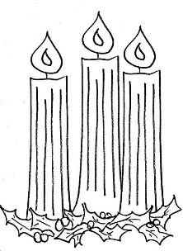
Lite Brite--Lending Lite
Matthew 5:14-16
Big Idea: In Matthew 5:14-16 Jesus gives us three reminders about fulfilling God’s highest purpose for us: to be His light in a dark world.
I. We are d_____________ to be God’s light
A) God is the p____________ behind our light
1 John 1:5; John 8:12; John 12:36a

B) God saves us for the p__________ of being light Matthew 5:14a
In Christ we have been….
1. …r___________ Colossians 1:12-13
2. …r_____________ 1 Thessalonians 5:5

C) God p____________ us in the place He wants our light to shine
Matthew 5:14b; Philippians 2:15b
II. We should not to d____________ God’s light Matthew 5:15a
A) Don’t pretend to be light but practice darkness 1 John 1:6

B) Do what is necessary to prevent darkness
How to live as a child of the light. Ephesians 5:8-17
1. vv.10 & 17b_______________________________________________________________
How? 1 Thessalonians 5:21 & Romans 12:2
2. v.11 _________________________________________________________________________________
Psalm 1:1-2
3. v.15 ___________________________________________
III. We should d______________ God’s light Matthew 5:15b-16
Acts 1:8; 2 Corinthians 5:20a

