Mission Models
Big Idea: We need to evaluate and improve our fulfillment of Christ’s mission to save the world by examining two mission models.
I. Jesus’ model for d____________—the Funnel
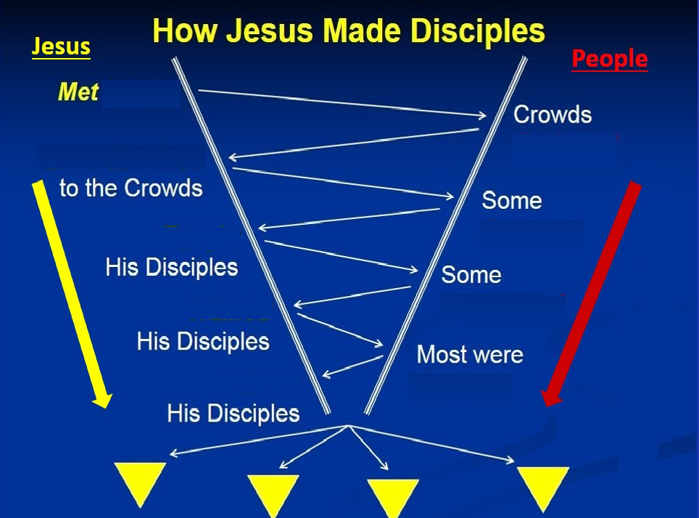

`

1 Jesus – met n_________ Crowds Gathered
Matthew 8:14-16
2. Jesus p__________Some believed
John 8:28-30
3. Jesus t____________Some committed
Matthew 16: 13-18
4. Jesus t__________ Most were faithful
Luke 10:1-17
5) Jesus s______ his disciplesThey followed Jesus’ model
John 20:21; Matthew 28:18-20; Mark 16:15
II. The Disciples’ r____________ model—the Triangle

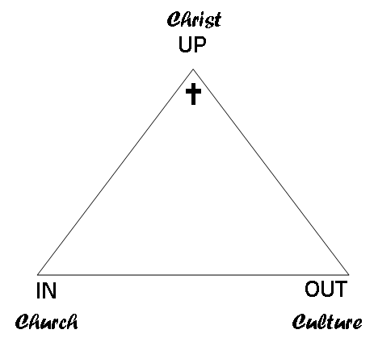
________
________
________

1. Up—Are you moving closer to ____________?
Matthew 22:37-38; John 17:3

2. In—Are you moving closer to the c_________/Christians?
1John 4:10-12; 1 Corinthians 12: 24b-25 & 27

3. Out—Are you moving closer to the c________/non-C__________?
Matthew 11:19a; Acts 1:8; Acts 17:23

